PIZZA SALES QURIES IN SQL

1. **Total Revenue**

Select sum(total_price) as Total_Revenue

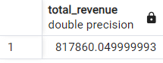from pizza;

1. **Spend per order**

Select sum(total_price)/count(distinct order_id)

as spend_per_order

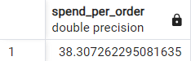 from pizza ;

1. **Total Pizza sold**

Select sum(quantity) as total_pizza_sold

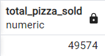 from pizza ;

1. **Total order placed**

Select count(distinct order_id ) as Total_order_placed

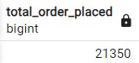 from pizza;

1. **Average pizza per order**

Select sum(quantity)/count(distinct order_id) as

average_pizza_per_order

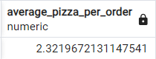 from pizza ;

1. **Weekly Total Orders**

Select

To_char(order_date, ‘day’) as month , count(distinct order_id) as total_orders

From pizza

Group by To_char(order_date,’day’)

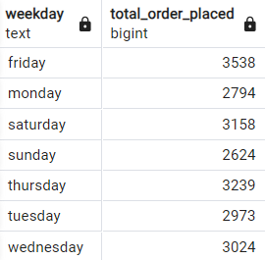Order by total_orders desc ;

1. Monthly Total Orders

Select To_char(order_date,’month’) as month, Count(distinct order-id) as total_orders

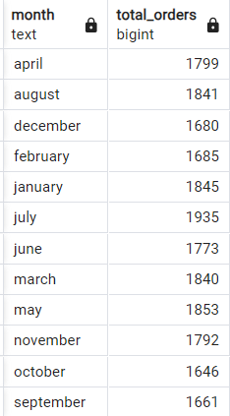 From pizza Group by To_Char(order_date, ‘month’) Order by Total_orders desc;

**Pizza Category Sales Percentage**

Select pizza_category , sum (total_price) *100/(select sum(total_price) from pizza) as pct

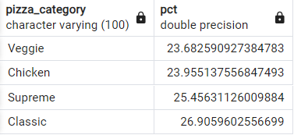 From pizza Group by pizza_category order by pct;

* 1. **Pizza Size Sales Percentage**

Select pizza_size , sum(total_price)*100/(select sum(total_price) from pizza) as pct

From pizza

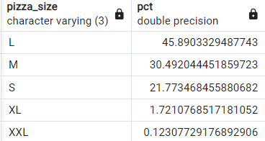 Group by pizza_size order by pct desc;

1. **Top 5 Selling pizzas**

Select pizza_name , sum(pizza_price) as Total_revenue

From pizza

Group by pizza_name

Order by Total_revenue desc

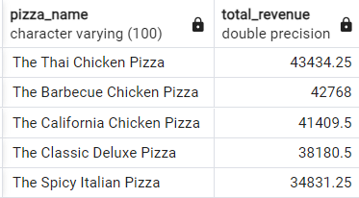Limit 5;

1. **Bottom 5 selling pizzas**

Select pizza_name , sum(pizza_price) as Total_revenue

From pizza

Group by pizza_name

Order by Total_revenue ASC

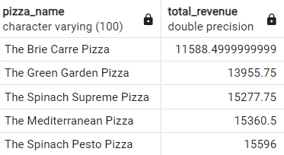Limit 5;

1. **Top 5 Pizzas by Quantity**

Select pizza_name ,

Sum(quantity ) as total_quantity

From pizza

Group by pizza_name

Order by total_quantity desc

Limit 5;

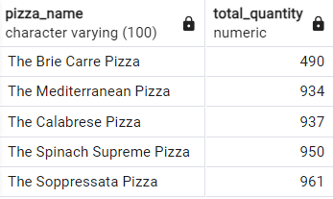

1. **Bottom 5 Pizzas by Quantity**

Select pizza_name ,

Sum(quantity ) as total_quantity

From pizza

Group by pizza_name

Order by total_quantity asc

Limit 5;

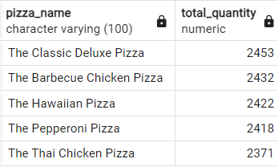

1. **Top 5 Pizzas by Total Orders**

Select pizza_name,

Count(distinct , order_id) as Total order

From pizza

Group by pizza_name

Order by Total order desc

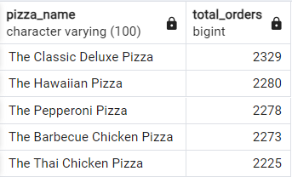Limit 5 ;

1. **Bottom 5 Pizzas by Total Orders**

Select pizza_name,

Count(distinct , order_id) as Total order

From pizza

Group by pizza_name

Order by Total order asc

Limit 5 ;

